**Tableau Application to Discover the Multidimensional Poverty Index Dataset**

How Poverty Are the Developing Countries Suffering?

***(Full name: Chi Nguyen Chau, SID: 22156675)***

**Abstract**

*Poverty is a complicated phenomenon having several negative effects on society. Survey about poverty provides a multidimensional dataset required a visualization tool to support data exploration and insight drawing. This report introduced Tableau as a robust tool serving this purpose and manipulated it to discover the MPI dataset. The dashboard created by Tableau tool revealed that many people in developing countries are poor and deprived of multidimensional poverty, that Sub-Saharan Africa and South Asia are the most deprived regions, and that the poverty status has been improved compared to the previous survey.*

1. **Introduction**

Poverty remains one of the most concerned problems in the world and its definition is still being studied with both unidimensional and multidimensional approaches (Haushofer & Fehr, 2014; Vargas & Espasandín-Bustelo, 2022). When it comes to multidimensional approaches, these survey’s results return tabular datasets with many dimensions which are difficult to explore the data and draw insights as well. This report aims to try using Tableau – a popular visualization tool to decompose the poverty dimensions, visualize them and discover the current poverty status in developing countries. The structure of report consists of four main parts: introduction stating the purpose of report, technical details reviewing some knowledges about Tableau and visual techniques applied in this report, discussion and findings which introduces the Multidimensional Poverty Index (MPI) and discusses on the effect of poverty in society as well as the status of poverty in developing countries based on MPI dataset, and then conclusion.

1. **Technical Details**

The given dataset is about the MPI in developing countries which is a complex dataset containing two tables. The first one includes 118 rows in which 111 rows represent 111 countries in the survey, 6 rows for the regions those countries belong to and 1 row for the summary of all countries, and 15 columns represent the features of the MPI. The second table is about the change over time of MPI and the indicators which were used to calculate the index for 84 countries. To visualize this dataset, this report used Tableau tool and techniques including line chart, spider chart, donut chart, shape and number, Choropleth map, dashboard and interaction.

* 1. **Tableau**

*Tableau* is one of the most popular business intelligence (BI) tools today and very useful in data analytics (Batt et al., 2020; Lavanya et al., 2023). It can be used to create many types of charts and dashboards which are aesthetically nice and easy to understand (Lavanya et al., 2023). It also supports the storytelling function which users can use to make up a story by combining some story points (highlighted charts and dashboards) and adding their own words to tell readers the story. Some advantages when considering using Tableau rather than other BI tool include easy to implement by drag-and-drop actions, able to connect to many types of data sources, high performance in dealing with massive datasets and beautiful and interactive outcomes. However, the cost of investing in this tool is expensive which makes scalability become a problem with small and medium-sized enterprises. It also doesn’t support importing custom visuals which means that each custom visual must be created from the beginning (compared to Power BI which support “create and reuse”, save a lot of time for users). And another drawback is that users cannot schedule for automatic refreshing the report while this feature is supported very well in Power BI (Lavanya et al., 2023; Absent Data, n.d.; Padma, 2021). *(See Table 1 for more comparison between some other visualization tools)*

*Tableau Prep Desktop*: Although Tableau Desktop allows processing data but not for complex tasks such as pivot or unpivot. In 2018, Tableau released the Tableau Prep Desktop as another tool to prepare data before importing to Tableau Desktop for visualizing. It also supports creating and storing the task flows for rerun when new data arrives. This report used this tool and Microsoft Excel for data processing.

Figure 1: Pre-processing MPI dataset with Tableau Prep Desktop

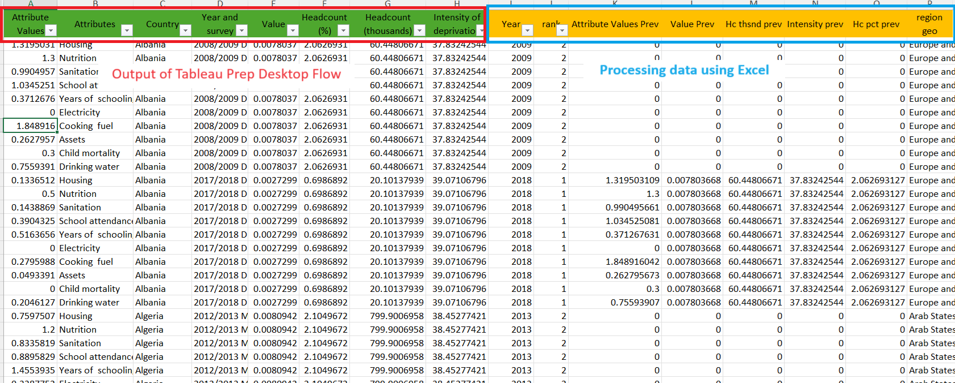

Figure 2: Pre-processing MPI dataset with MS Excel

* 1. **Line chart**

*Line chart* is a collection of points connected ordinally by straight lines, usually used to show a trend in an interval time and sometimes to compare the variance between trend lines (Patra, 2014; “Line chart,” 2024). It can work well with continuous data but is incompatible with categorical data. This type of chart is classic, well-known and easy to implement but “limited in large scale analysis, generally not integrated with interaction and not suitable to display high dimensional data” (Quang, 2024b).

In this report, line charts were used to represent the change of the MPI and its main components (headcount and intensity of deprivation) for each country in the survey. The implementation is so easy, just drag-and-drop the appropriate dimension and measure to Columns and Rows, then change Marks type to Line and format the chart as expectation (see Figure 5).

Figure 3: Line chart - Headcount

Figure 4: Line chart - Intensity

Figure 5: Line chart - MPI

Figure 6: Create line chart in Tableau

* 1. **Spider chart**

*Spider chart* is used to plot hypervariated data in 2D space (Srinivasa et al., 2018). Similar to parallel coordinate and star plots, value is represented by a point on a coordinate axis, points are jointed by straight line and polygon is filled by color which represents an item in the dataset (Quang, 2024b). This type of chart generally produces a nice outcome and helps to understand dataset easily (Srinivasa et al., 2018). However, its drawback is not suitable for dataset with massive items or dimensions (Quang, 2024b).

This report used spider chart to visualize the indicators which are main measurements to calculate MPI. The implementation of this chart is more complex than line chart but easy by following the guideline in tutorial video at this link (<https://www.youtube.com/watch?v=826y-AJVHR8>).

Figure 7: Spider chart

Figure 8: Create Spider chart in Tableau

* 1. **Donut chart**

*Donut chart* is a variance of pie chart and have a blank circle space in the center of pie chart to display more information (Siirtola, 2014). It can be used to represent the proportion with one more measure in the center. It is easy to implement and understand but inefficient in case many items need to be displayed.

Considering that MPI is contributed by three group of factors including standards of living, health and education, this report utilized donut chart to display the proportion of those groups, combined with the value of MPI in the center to deliver to readers a general picture about the poverty of a country.

Figure 9: Donut chart

Figure 10: Create a donut chart in Tableau

(https://www.youtube.com/watch?v=dLhojoAuiEI)

* 1. **Shape and number**

Sometimes, we need to deliver only a single piece of information like the number of populations, total sales of the whole company or total cost spent in this year. In those cases, a big number or a number and a shape can be more effective than a chart. This can impress the importance of the number and make it more memorable (Evergreen, 2019).

Many discrete dimensions in the given dataset such as headcount, intensity, number of poor people, the percentage of people in severe poor and deprived, if we combine them into a chart, it will be too complex and hard to explain at a glance. Considering that, they were presented as *a circle and number inside* and then manipulated the proximality effect to place them at the appropriate position in the dashboard.

To create these shapes in Tableau, we drag and drop the measure to Label in Marks panel, change Marks type to Shape, choose the expected shape and adjust the color and size as on demand.

Figure 11: Shape and number

Figure 12: Create shape and number in Tableau

* 1. **Choropleth Maps**

*Choropleth maps* are used to represent spatial data in which “area are shaded or patterned in proportion to measurement and each spatial unit is filled with a uniform colour or pattern” (Quang, 2024c). Generally, maps are simple to understand, integrated well with data, able to combine location with various datasets and provide excellent data representation, insight and engagement (Quang, 2024c).

Tableau supports a robust function to create maps. When we import the country name dimension, this tool will detect it and generate the longitude and latitude automatically which are used when creating a map.

This report used Choropleth map to visualize the distribution of MPI around the world. Through it, we can identify easily which countries are diving deeply into poverty.

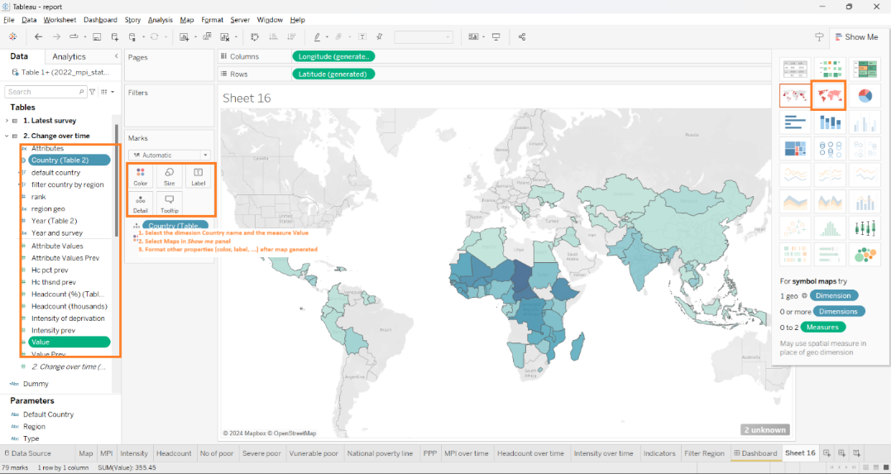

Figure 13: Create map in Tableau

* 1. **Dashboard and Interaction**

*Dashboard* is set of views placed simultaneously within a screen in which each view presents one or more dimensions of a multidimensional dataset. Thus, we can gather overall insights as well as details about the data at the same time.

*Interaction* is one of main components in an information visualization system and regards where the action is (Quang, 2024a). Applying interactions to dashboard can help to represent data not only in general but also in detail manner. Moreover, this can enhance the user experience when they interact with the dashboard.

There are many types of interactions including comparing, adding variables, sorting, filtering, highlighting, zooming and paning, aggregating, re-expressing, re-visualizing, annotating, bookmarking and accessing details on demand (Quang, 2024a). In this report, highlighting and filtering are used as interactions to discover the data in more contexts.

* The first controlleris a selection pane which will apply the filter by region to the map and shape. Highlighting is also applied in this controller to notice which region is currently displaying.
* The second controller is the map which will apply the filter by country to other charts and shape when users select a country on the map directly. Highlight is also applied in the map to notice which country is selected.
* The last controller is the dropdown in the upper-right corner of the map which provides the option showing value in the map as MPI, change of MPI, change of headcount or change of intensity (compared to previous period).

Figure 14: Dashboard and controller 1

Figure 15: Dashboard and controller 2

Figure 16: Dashboard and controller 3

1. **Discussion and Findings**
   1. **Multidimensional Poverty Index**

*Multidimensional Poverty Index* is a tool to measure global poverty as well as “track the progress against the first goal of Sustainable Development Goal (SDG)” (Alkire et al., 2019). It is measured by the degree of population under poor and deprived living conditions and how intense their poor is. The poor are surveyed in three dimensions of poverty (health, education and standard of living) which are contributed from 10 indicators including nutrition, child mortality, years of schooling, school attendance, cooling fuel, sanitation, drinking water, electricity, housing and assets. The lower the MPIs are, the less poor the countries are suffering. (*For more details about the technical in calculating MPI, please visit this* [*link*](https://hdr.undp.org/sites/default/files/2021-22_HDR/hdr2021-22_technical_notes.pdf))

* 1. **How does poverty impact society?**

Poverty generally has a lot of negative effects on various aspects of society including education, health, psychology and politics (Haushofer & Fehr, 2014; Mood & Jonsson, 2016; Lee, 2011; Hakim Haider et al., 2018; Ali et al., 2018).

The poor have a low rate of enrollment in school and tend to terminate earlier. This restricts their potential, reduces their employment opportunities which affects their financial status, housing affordable and are able to put them into the chronic poverty trap (Lee, 2011; Hakim Haider et al., 2018). Besides that, they also cannot be in a good health condition which leads to “a high rate of infant mortality, earlier adulthood mortality and mental disorder” (Hakim Haider et al., 2018).

In psychology, poverty causes stressful and negative feelings which forms the poor limited vision, non-risk tolerance (Haushofer & Fehr, 2014), lack of confidence, shame, anger (Ali et al., 2018), frustration, discontentment (Hakim Haider et al., 2018), harms their social relationships (Mood & Jonsson, 2016) and even worser lead to divorce and violence in family (Hakim Haider et al., 2018). Furthermore, they are more prone to commit illegal actions or be victims of criminal behaviors as well (Hakim Haider et al., 2018).

In politics, poverty has more harmful effects for political participation which means the constraints in participating the political life (Mood & Jonsson, 2016), may increase the risk of war when the poor countries have high risk of being attacked by other neighbor countries due to their resources, causes the massive emigration and might lead to terrorism and genocide in the worst-case scenario (Hakim Haider et al., 2018).

* 1. **A view of poverty in developing countries through MPI**

In average, about 19% of population in developing countries are in poverty and another 15% are vulnerable to the deprivation. This means that besides over 1 billion poor people, there still exist over 800 million people being at risk of suffering multiple deprivations. The intensity of poor people is about 48.96% with the inequality +/- 1.75% means that most of them are experiencing severe multidimensional deprivations or very close to that threshold and the PPP is 14.23% shows that more than 70% of poor people live with below $1.9 a day.

Figure 17: Summary in all developing countries

Taking a closer look at it, about 531 million out of 1 billion poor people are living in Sub-Saharan Africa region, take into account nearly a half of the poor people. The headcount 53.42% and the vulnerable 18.74% indicate that over 70% of population in this region are living lower the standard living conditions at least 20%. Furthermore, the PPP shows that 41% are living on under $1.9 a day. The second poverty region is South Asia with more than 300 million poor people accounting for a third of total poor people and most of them live with under $1.9 a day (PPP is 19.04% out of headcount 20.46%). Meanwhile, the poverty status in the remaining regions is much lower than these two regions.

Figure 18: MPI in Sub-Saharan Africa region

Figure 19: MPI in South Asia region

The dashboard also shows that compared to the previous survey, the MPIs have been improved. The change not only comes from the decrease in the number of poor people but also in the intensity of poverty. This improvement provides a positive signal for the SDG Agenda, implies that poverty removal is a possible mission.

Figure 20: Change of MPI

Figure 21: Change of headcount

Figure 22: Change of intensity

1. **Conclusion**

Tableau is a robust visualization tool supporting to generate beautiful visuals, design nice and interactive dashboards which help readers easily extract insights from tabular datasets. It also provides some features for pre-processing data allowing users to create data flow for reusable purposes. However, this tool doesn’t support automatic refreshing schedule and the cost is expensive which cannot be affordable for the small and medium-sized enterprises. Using Tableau to decompose the MPI dataset, we found that many people in developing countries are living in poor and even severely deprived conditions. Many of them are even living on below $1.9 a day. Two regions having the greatest number of poor people are Sub-Saharan Africa and South Asia accounting for more than 85% of poor people in developing countries. We also found that poverty has been improved compared to the previous survey implying that the policies against poverty are efficient and the goal of removing poverty out of the world is possible.

***Limitation***

Actually, there are many facets of poverty in this dataset which still haven’t been extracted because of Tableau skill and time constraints such as the three main factors of MPI and the indicators which indicates what the poor are experiencing deprived or which country is the poorest. This report discussed the consequences of poverty but left behind the actions that should be taken to deal with the poverty happening in these countries, which is out of scope of it. Further studies are encouraged to discover more findings as well as suggest some ideas about how to decrease poverty in developing countries.

**Table 1: The comparison of some BI tools (Lavanya et al., 2023)**

|  |  |  |
| --- | --- | --- |
| Name of Tool | Advantage | Disadvantage |
| Tableau | User-friendly with non-Tech requirements | Professional version Expensive for SMEs; Manual update of Data does not allow auto-scheduling |
| Power BI | Affordable for a Desktop version suitable for SMEs; Supportive for Non-Datawarehouse organizations; Automated data refresh and report generations; customized access keys for security | No data cleaning possible; higher difficulty levels for learning |
| Google Data Studio | Easy integration with all Google Cloud Applications; Flexible Integration; Built-in data connectors; Dynamic Controls; real-time collaborations; Unlimited access to widgets; Fully Open Source | Difficult learning curve; Limited with functionalities; Data processing limitations; |
| D3.js | Flexible and powerful; Variety of visualization; supports animation and data interactions; Active community support; compatible with customized datasets; versatile in visualization; built on JavaScript libraries | The difficult learning curve for nonprogrammers; Complex set up; tough for beginners needs detailed step-by-step learning before full application; uncertain performance issues; |
| Matplotlib | Wide range of visualization packages; fully customizable; cross-platform support; interactive plotting; massive user community for support | Difficulty in learning curve; verbose syntax; Limited for 3D and animation plotting; Limited interactivity between other visualization python packages; |
| Seaborn | Wide range of default multiple plotting; integrates strongly with Pandas and NumPy; inbuild statistical tests; | Rus into out of memory often; not fully embedded into Python; |
| Plotly | Programmatically cost-effective; empowers visualization with back-end and front-end Machine learning support; Aesthetically pleasing; | No automation process at all; too many separate libraries; slow in speed and consumers high processes speed; |
| QlikView | Allows new relationship identification among data nodes; end-to-end solution; | Exporting plots gets challenging to a power point or PDF, tough program configurations; |
| SAS Visual Analytics | Self-Service BI tool; highly interactive; easy to learn; no need for programming skills; predictive modules; powerful data visualization; a variety of outputs provided for better visualization | Highly expensive; poor graphic presentations |
| IBM Cognos Analytics | Highly secured for corporate data visualizations; AL and ML-based data analytics modelling tools; greater flexibility; cell-by-cell analytics; easy to learn; seamless integrations with Cognos; easy file storages and report generations system; | Expensive; too many modelling tools creating confusion; missing simple and small plotting features; |

**REFERENCE**

Absent Data. (n.d.). *Advantages and Disadvantages of Tableau*. Retrieved June 6, 2024, from https://absentdata.com/advantages-and-disadvantages-of-tableau/

Ali, S., Sensoy Bahar, O., Gopalan, P., Lukasiewicz, K., Parker, G., McKay, M., & Walker, R. (2018). “Feeling less than a second class citizen”: Examining the emotional consequences of poverty in New York City. *Journal of Family Issues*, *39*(10), 2781-2805.

Alkire, S., Conceição, P., Barham, A., Calderón, C., Conconi, A., Dirksen, J., Espinal, F. C., Evans, M., Hall, J., Jahic, A., Kanagaratnam, U., Kivilo, M., Kovacevic, M., Kovesdi, F., Mitchell, C., Nogales, R., Oldiges, C., Ortubia, A., Pinilla-Roncancio, M., …Walkey, C. (2019). *Global Multidimensional Poverty Index 2019: Illuminating Inequalities.* The United Nations Development Programme and Oxford Poverty and Human Development Initiative. https://hdr.undp.org/system/files/documents/mpi2019publication.pdf

Batt, S., Grealis, T., Harmon, O., & Tomolonis, P. (2020). Learning Tableau: A data visualization tool. *The Journal of Economic Education*, *51*(3-4), 317-328.

Evergreen, S. D. (2019). *Effective data visualization: The right chart for the right data*. SAGE publications.

Hakim Haider, M., Kumar, S., Hakim Haider, M., & Kumar, S. (2018). Consequences of Poverty in Afghanistan. *Poverty in Afghanistan: Causes, Consequences, and Coping Mechanisms*, 127-144.

Haushofer, J., & Fehr, E. (2014). On the psychology of poverty. *science*, *344*(6186), 862-867.

Lavanya, A., Sindhuja, S., Gaurav, L., & Ali, W. (2023). A comprehensive review of data visualization tools: features, strengths, and weaknesses. *Int. J. Comput. Eng. Res. Trends*, *10*(01), 10-20.

Lee, S. (2011). Analyzing intra-metropolitan poverty differentiation: causes and consequences of poverty expansion to suburbs in the metropolitan Atlanta region. *The Annals of Regional Science*, *46*, 37-57.

Line chart. (2024, March 30). In *Wikipedia*. https://en.wikipedia.org/wiki/Line_chart

Mood, C., & Jonsson, J. O. (2016). The social consequences of poverty: An empirical test on longitudinal data. *Social indicators research*, *127*, 633-652.

Padma (2021, April 12). *What are the advantages and disadvantages of using Tableau?* H2K Infosys. https://www.h2kinfosys.com/blog/what-are-the-advantages-and-disadvantages-of-using-tableau/

Patra, S. K. (2014). Data visualization for hybrid application: the challenges in choosing an optimal library for line chart. *Int. J. Emerg. Sci. Eng.(IJESE)*, *2*(10), 12-15.

Quang, V. A. (2024a). *Week eight: Interaction and Navigation* [PowerPoint slides]. vwus Western Sydney University. <https://vuws.westernsydney.edu.au/ultra/courses/>

Quang, V. A. (2024b). *Week five: Multi-dimensional Data Visualisation – Part I* [PowerPoint slides]. vwus Western Sydney University. https://vuws.westernsydney.edu.au/ultra/courses/

Quang, V. A. (2024c). *Week seven: Spatio-temporal or Geospatial/Geographic Data Visualisation* [PowerPoint slides]. vwus Western Sydney University. https://vuws.westernsydney.edu.au/ultra/courses/

Siirtola, H. (2014, September). Bars, pies, doughnuts & tables–Visualization of proportions. In *Proceedings of the 28th International BCS Human Computer Interaction Conference (HCI 2014)*. BCS Learning & Development.

Srinivasa, K. G., Siddesh, G. M., & Srinidhi, H. (2018). Advanced visualization. *Network Data Analytics: A Hands-On Approach for Application Development*, 361-383.

Tableau. (n.d.). *Dashboards*. Retrieved June 6, 2024, from https://help.tableau.com/current/pro/desktop/en-us/dashboards.htm

Vargas, J. G., & Espasandín-Bustelo, F. (2022). Intellectural Structure of the “Extreme Poverty” Research Field. In *Multidimensional Approach to Local Development and Poverty: Causes, Consequences, and Challenges Post COVID-19* (pp. 1-20). IGI Global.